Ls

ls -r

ls -lart

pwd

cd /

cd ..

/ root directory

Most Common Directories are in Unix ---- (i**) etc** (**ii) bin** (iii) **usr** (iv) tmp (v) dev

mkdir

mv

cp

touch (touch file name)

To make a hidden file

touch .file name

To view the hidden file

ls -a

In Unix File name is case sensitive.

So basically you can create file name with same name but different cases

rm

clear

history

eco “Hello world”

printf “Hello world” or printf “Hello world\n”

$ means Regular user.

When you type any command with “sudo” you need to type password

When you type “sudo su” you will become superuser and you get all admin privileges.

“$” sign will change into “#”

“sudo su” is not recommended for use.

Please use your Regular user id id for Normal work and whenever required you use “Sudo”.

How to make a normal user to Sudo user.

**Usermod -aG sudo testuser** (This will make “testuser” a Sudo User)

There is two command to update software List in Ubuntu.

**apt-get update (Old)**

**apt update (new)**

Another command is “app upgrade” which installs software in the system

**app upgrade**

**Installing Software**

Sudo apt install snail (snail --- one software)

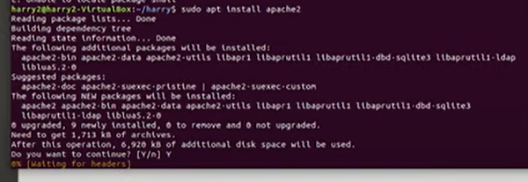

**Permission:**

**To Check Process:**

**“Top”** command shows the process which consumes most resources of the systems.

“q” – quit from “Top” mode.

**“ps” –**

Process currently running in the system

**ps -a**

“ps -a” also do the same thing along with all background process

**Kill**

**Vim Editor**

# vim file.txt

# you can check the permission of the file by “ls -l file name” command.

# You can give appropriate permission to the file by “chmod” command.

Command Mode (ESC)

Insert Mode (i)

Saving and Closing the File

:w! – Save the file and keep it open (!--- is mandatory for some Unix flavor)

:q! – Quit without saving

:wq! – Save the file and quit

To move left, press h

To move right, press l

To move down, press j

To move up, press k

dd- Delete Line

yy (yank) (copy)

p (Paste)

**How to check Disk Space in Linux:**

**Linux df command**

The **df** command stands for "disk-free," and shows available and used disk space on the Linux system.

**df -h** shows disk space in human-readable format

**df -a** shows the file system's complete disk usage even if the Available field is 0

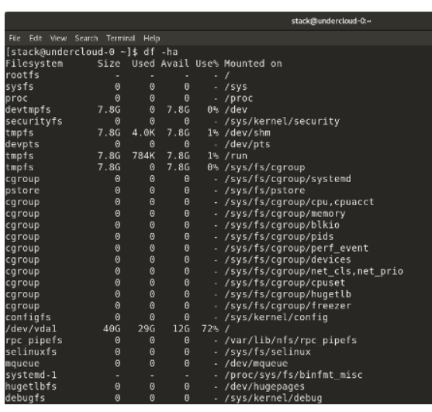

df -T shows the disk usage along with each block's filesystem type (e.g., xfs, ext2, ext3, btrfs, etc.)

df -i shows used and free inodes

**Linux du command**

du shows the disk usage of files, folders, etc. in the default kilobyte size

du -h shows disk usage in human-readable format for all directories and subdirectories

du -a shows disk usage for all files

du -s provides total disk space used by a particular file or directory

**Linux fdisk -l command**

fdisk -l shows disk size along with disk partitioning information

**Firewall:**

Uwf app list – Which are the applications available now.

Uwf status -

Uwf allow OpenSSH -

Uwf enable

